(Put a title here.)
(Add more info of some sort here?)
These results are from an ‘rmd’ script created 26 October 2020.

This R program reads item scores data from an Omega-IScores.csv file, and then invokes the Omega function in the psych package to produce results.
Omega-IScores.csv files are created by Lertap. A reference to the respective Lertap help page is here. The psych package’s page at the CRAN site is here. A document which discusses the extensive capabilities of the psych package is also available; a related document devoted exclusively to omega is this one. The Schmid-Leiman solution incorporated in the psych package is detailed here.
The Omega-IScores.csv file used in this analysis was obtained from this folder:
[1] "G:/JASP work Oct 2020/FIMS"

A few of the data records from the csv file are displayed below. The first column below has a record number inserted by R, the columns to the right of that must have item scores for the items – make sure that this is the case. There must only be item scores after the record number. (Refer here for help.)
Q1 Q2 Q3 Q4 Q5 Q6 Q7 Q8 Q9 Q10 Q11 Q12 Q13 Q14
1 1 0 1 1 0 1 0 0 1 0 0 0 0 1
2 0 1 1 0 0 0 0 1 0 0 0 0 0 1
3 1 0 1 0 0 0 0 0 0 1 0 0 0 1
4 1 1 1 1 0 1 1 0 0 0 0 0 0 0
5 1 1 1 1 0 1 0 1 0 1 0 0 0 1
6 1 1 1 0 0 0 0 0 0 1 0 1 0 0

Basic descriptive item statistics are as follows.
vars n mean sd median trimmed mad min max range skew kurtosis se
Q1 1 6371 0.77 0.42 1 0.84 0 0 1 1 -1.30 -0.30 0.01
Q2 2 6371 0.76 0.43 1 0.83 0 0 1 1 -1.23 -0.49 0.01
Q3 3 6371 0.85 0.36 1 0.93 0 0 1 1 -1.92 1.69 0.00
Q4 4 6371 0.57 0.49 1 0.59 0 0 1 1 -0.29 -1.92 0.01
Q5 5 6371 0.16 0.37 0 0.08 0 0 1 1 1.82 1.33 0.00
Q6 6 6371 0.80 0.40 1 0.87 0 0 1 1 -1.47 0.16 0.01
Q7 7 6371 0.34 0.47 0 0.30 0 0 1 1 0.67 -1.56 0.01
Q8 8 6371 0.40 0.49 0 0.37 0 0 1 1 0.41 -1.83 0.01
Q9 9 6371 0.26 0.44 0 0.20 0 0 1 1 1.10 -0.79 0.01
Q10 10 6371 0.61 0.49 1 0.64 0 0 1 1 -0.46 -1.79 0.01
Q11 11 6371 0.20 0.40 0 0.13 0 0 1 1 1.47 0.16 0.01
Q12 12 6371 0.23 0.42 0 0.17 0 0 1 1 1.25 -0.44 0.01
Q13 13 6371 0.19 0.39 0 0.11 0 0 1 1 1.61 0.58 0.00
Q14 14 6371 0.69 0.46 1 0.74 0 0 1 1 -0.84 -1.29 0.01

Output from the Omega function follows
Loading required namespace: GPArotation
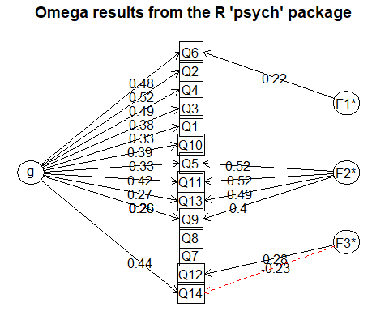
Omega results from the R 'psych' package
Call: omegah(m = m, nfactors = nfactors, fm = fm, key = key, flip = flip,
digits = digits, title = title, sl = sl, labels = labels,
plot = plot, n.obs = n.obs, rotate = rotate, Phi = Phi, option = option,
covar = covar, echo = FALSE)
Alpha: 0.7
G.6: 0.7
Omega Hierarchical: 0.53
Omega H asymptotic: 0.73
Omega Total 0.73
Schmid Leiman Factor loadings greater than 0.2
g F1* F2* F3* h2 u2 p2
Q1 0.33 0.13 0.87 0.86
Q2 0.52 0.31 0.69 0.86
Q3 0.38 0.18 0.82 0.83
Q4 0.49 0.28 0.72 0.86
Q5 0.33 0.52 0.38 0.62 0.29
Q6 0.48 0.22 0.29 0.71 0.79
Q7 0.05 0.95 0.47
Q8 0.05 0.95 0.35
Q9 0.26 0.40 0.23 0.77 0.30
Q10 0.39 0.18 0.82 0.86
Q11 0.42 0.52 0.44 0.56 0.39
Q12 0.28 0.09 0.91 0.00
Q13 0.27 0.49 0.31 0.69 0.23
Q14 0.44 -0.23 0.27 0.73 0.71
With eigenvalues of:
g F1* F2* F3*
1.80 0.19 1.01 0.19
general/max 1.78 max/min = 5.45
mean percent general = 0.56 with sd = 0.3 and cv of 0.53
Explained Common Variance of the general factor = 0.57
The degrees of freedom are 52 and the fit is 0.02
The number of observations was 6371 with Chi Square = 149.23 with prob < 2.5e-11
The root mean square of the residuals is 0.01
The df corrected root mean square of the residuals is 0.02
RMSEA index = 0.017 and the 10 % confidence intervals are 0.014 0.02
BIC = -306.26
Compare this with the adequacy of just a general factor and no group factors
The degrees of freedom for just the general factor are 77 and the fit is 0.35
The number of observations was 6371 with Chi Square = 2230.01 with prob < 0
The root mean square of the residuals is 0.07
The df corrected root mean square of the residuals is 0.08
RMSEA index = 0.066 and the 10 % confidence intervals are 0.064 0.069
BIC = 1555.53
Measures of factor score adequacy
g F1* F2* F3*
Correlation of scores with factors 0.79 0.31 0.73 0.42
Multiple R square of scores with factors 0.62 0.10 0.53 0.18
Minimum correlation of factor score estimates 0.24 -0.80 0.07 -0.64
Total, General and Subset omega for each subset
g F1* F2* F3*
Omega total for total scores and subscales 0.73 0.63 0.61 0.11
Omega general for total scores and subscales 0.53 0.54 0.20 0.11
Omega group for total scores and subscales 0.15 0.08 0.41 0.00

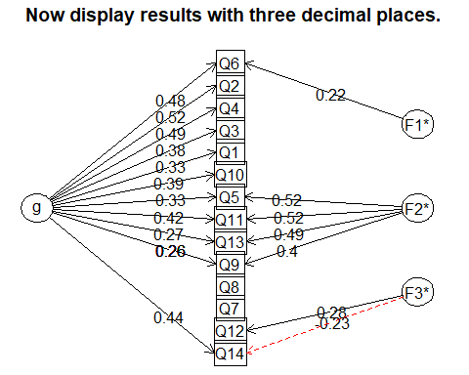
Now display results with three decimal places.
omegah(m = MCQitems, digits = 3, title = "Now display results with three decimal places.")
Alpha: 0.697
G.6: 0.7
Omega Hierarchical: 0.533
Omega H asymptotic: 0.732
Omega Total 0.728
With eigenvalues of:
g F1* F2* F3*
1.80 0.19 1.01 0.19
The degrees of freedom for the model is 52 and the fit was 0.023
The number of observations was 6371 with Chi Square = 149.232 with prob < 0
The root mean square of the residuals is 0.013
The df corrected root mean square of the residuals is 0.019
RMSEA and the 0.9 confidence intervals are 0.0171 0.014 0.0204
BIC = -306.263Explained Common Variance of the general factor = 0.565
Total, General and Subset omega for each subset
g F1* F2* F3*
Omega total for total scores and subscales 0.728 0.625 0.614 0.109
Omega general for total scores and subscales 0.533 0.543 0.203 0.107
Omega group for total scores and subscales 0.148 0.082 0.411 0.001

That’s it, all done for now, adios amigos, Larry Nelson, l.nelson@curtin.edu.au

